Ideation Phase
Define the Problem Statements

Date | 5 February 2026
Team ID | Sanket Yadav, Shreyash Nimbalkar, Parth Jadhav, Mayur Dhole
Project Name | Strategic Product Placement Analysis: Unveiling Sales Impact with Tableau Visualization
Maximum Marks | 2 Marks

Customer Problem Statement Template:
Defining the problem statement is a crucial step in understanding the core challenges faced by business users in this project. The primary objective is to analyze how product placement strategies influence sales performance, using Tableau for effective data visualization and decision-making support.
The core problem in this project is that retail managers and analysts lack clear, visual insights to understand how product placement affects sales. Existing data is often scattered or non-interactive, making it difficult to make quick, informed decisions. This project aims to solve that by using Tableau to create interactive dashboards that reveal the sales impact of different product placements, helping users make smarter, data-driven decisions with confidence.

Problem Statement 1: Regional Sales Manager in a Retail Chain
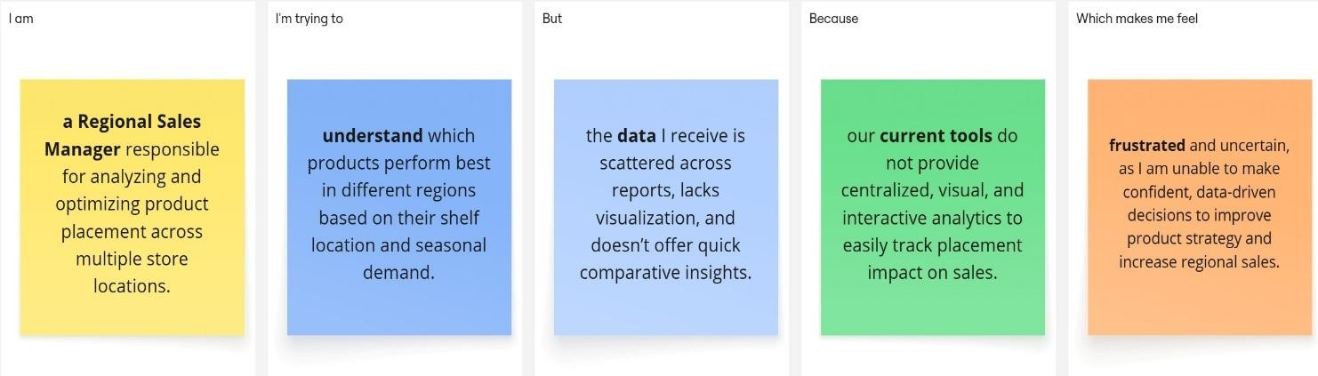

Problem Statement 2: Marketing Analyst at a Fast-Moving Consumer Goods (FMCG) Company
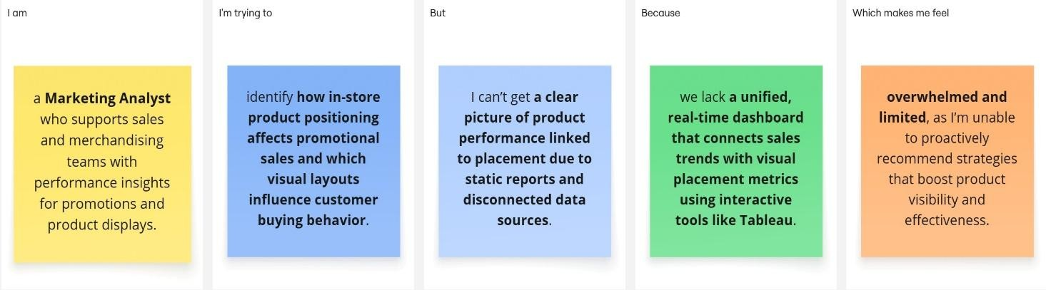

Problem  Statement (PS) | I am | I’m trying to | But | Because | Which makes me feel
PS-1:  Regional  Sales  Manager  in a Retail Chain | a Regional Sales Manager  responsible for analyzing and optimizing product placement across multiple store locations. | understand which products perform best in different regions based on their shelf location and seasonal demand. | the data I receive is scattered across reports, lacks visualization, and doesn’t offer quick comparative insights. | our current tools do not provide centralized, visual, and interactive analytics to easily track placement impact on sales. | frustrated and uncertain, as I am unable to make confident, datadriven decisions to improve product strategy and increase regional sales.
PS-2:  Marketing Analyst at a FastMoving  Consumer  Goods  (FMCG)  Company | a Marketing Analyst who supports sales and merchandising teams with performance insights for promotions and product displays. | identify how instore product positioning affects promotional sales and which visual layouts influence customer buying behavior. | I can’t get a clear picture of product performance linked to placement due to static reports and disconnected data sources. | we lack a unified, real-time dashboard that connects sales trends with visual placement metrics using interactive tools like Tableau. | overwhelmed  and limited, as I’m unable to proactively  recommend  strategies that boost product visibility and effectiveness.

